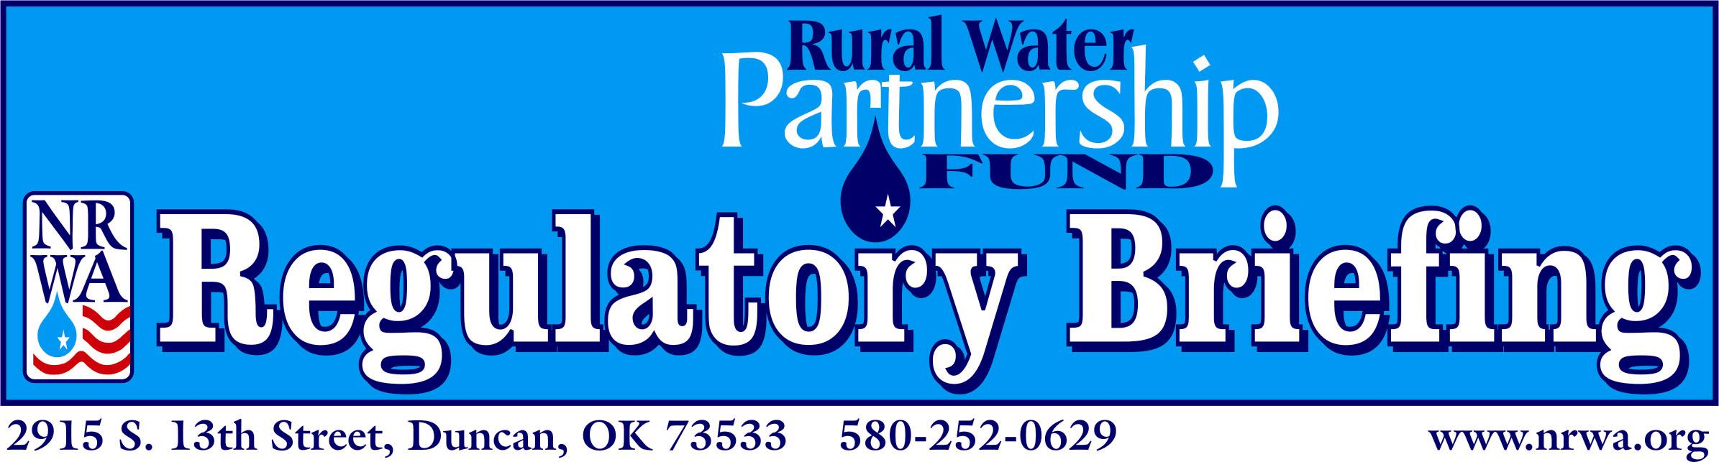

Coliform Bacteria, Regulatory Briefing

Prepared By:
Nancy L. Pontius
Pontius Water Consultants, Inc.
P.O. Box 150361
Lakewood, CO 80215
303-986-9923

November 14, 2002



National
Rural Water
Association

Copyright © 2004 by National Rural Water Association. Compilation copyright © 2004 by National Rural Water Association. All rights reserved. No part of this paper may be reproduced or transmitted in any form or by any means, electronic or mechanical, including photocopying, recording, or by any information storage and retrieval system, without permission in writing from the publisher.
National Rural Water Association, 2915 South 13th Street, Duncan, OK 73533, 580-252-0629, FAX 580-255-4476
http://www.nrwa.org, Printed in the United States of America.

Total coliform bacteria are regulated under the Total Coliform Rule (TCR) and are used as indicator organisms to indicate the presence of pathogens, and alert for possible fecal contamination. Coliform bacteria have been used in this way for decades. Treatment that removes and inactivates coliform bacteria should also reduce most pathogens to minimal levels. The US Environmental Protection Agency (USEPA) is considering revising the TCR, and the current status of this activity is reviewed in this briefing.

Occurrence
Coliform bacteria are widely present in the environment, including in surface water and some groundwaters. Coliform bacteria are a group of closely related single-celled microorganisms that are rod-shaped and in the family Enterobacteriaceae. The coliform group includes most species of Citrobacter, Enterobacter, Klebsiella, and Escherichia (E.) coli, and some species of Serratia and others.
Coliform bacteria normally exist in the intestinal tracts of warm-blooded animals and humans, and are eliminated in feces. In addition, most coliform bacteria can also exist widely in the environment, including in soil, surface water, and to a lesser extent, groundwater.
Fecal coliform bacteria are a subset of the total coliform group. Fecal coliforms cannot survive outside of humans or animals for long periods of time. E. coli is a major subset of the fecal coliform group. E. coli does not usually survive for long outside a human or animal, except possibly in warm water in the tropics.

Human Health Effects and Exposure
Most total coliform bacteria are benign and found in the intestines of every human.
Approximately 11 types (out of 140 types) of E. coli cause gastrointestinal disease in humans, and have been identified as the disease agent in various waterborne and food borne-disease outbreaks. Some strains cause fever or dysentery. In particular, E. coli 0157:H7 causes bloody diarrhea, and can cause blood loss and kidney failure, especially in young children. E. coli can be spread from person to person, and through contaminated food and water, and from direct contact with animals.
Some strains of Citrobacter, Enterobacter, Klebsiella, and Serratia marcescens coliform bacteria can cause septicemia and pneumonia in sensitive subpopulations that do not have the defenses of healthy adults. Microorganisms that can make weakened populations sick are called opportunistic pathogens.

Treatment
Conventional treatment is effective in removing coliform bacteria. Disinfection processes are effective in inactivating coliform bacteria, including chlorine, chloramines, chlorine dioxide, ozone, and ultraviolet (UV) treatment. Disinfectant residuals throughout the distribution system inactivate many coliform bacteria and pathogens entering through cross-connections and line breaks, and suppress bacterial growth and biofilm in static water areas.

Regulation
Specific requirements of the TCR have been in effect since Dec. 1990. The TCR requires all public water systems to monitor for the presence of coliform bacteria in their distribution systems at a frequency proportional to the number of people served. The maximum contaminant level goal (MCLG) for coliform bacteria is zero.
There are several concerns regarding the current TCR. TCR requirements may be inadequate to identify those water systems that are vulnerable to a waterborne-disease outbreak. Most systems with outbreaks serve less than 3,300 people. Under the current TCR’s minimum sample-collection requirements, a large or continuous source of contamination is needed to detect coliform bacteria in the few samples collected by small systems. However, water contamination that is sufficient to cause an outbreak can be intermittent and short lived. For most public water systems that reported an outbreak, the TCR required only one to three samples each month.
Another important issue regarding the TCR, is whether total coliform bacteria or different organisms should be used as indicators of a water’s microbiological quality. A National Research Council committee is studying indicator organisms and should release their report in the spring of 2004. Fecal coliforms and E. coli alone have been suggested as indicator organisms. Although they do not distinguish between human and animal contamination, these organisms are better indicators of recent fecal contamination than total coliform bacteria. However, densities of fecal coliform bacteria and E. coli are typically much lower than those for total coliform bacteria. Testing for total coliform bacteria is more conservative than testing for only fecal coliform bacteria or E. coli, because the absence of any coliforms ensures the absence of fecal coliforms and E. coli.
USEPA has proposed to revise the TCR. The Agency will assess the effectiveness of the current TCR in reducing public-health risk, and consider what technically-supportable alternative and/or additional monitoring strategies are available that would not be too costly, while maintaining or improving public health protection. If USEPA decides to revise the TCR, the agency will begin a detailed analysis of the issues, including health effects, costs, benefits, and occurrence.
Currently, USEPA is conducting public stakeholder meetings to collect public comments on distribution-system issues. Distribution-system requirements may be included in the TCR revisions or in a separate rule. After USEPA collects information from stakeholder comments, and from USEPA analyses and data collection, the Agency will decide whether or not to revise the TCR.
To test for coliform bacteria in water under the TCR, samples should be taken and analyzed using an EPA-approved presence/absence test. A test analyzing for both total coliform bacteria and E. coli simultaneously can cost approximately $16 per sample at a certified laboratory.

Francy, D., D. Helsel, and R. Nally. 2000. Occurrence and Distribution of Microbiological Indicators in Groundwater and Stream Water. Water Environment Research 72:2:152-161. March/April.
Nwachuku, N., G. Craun, and R. Calderon. 2002. How Effective is the TCR in Assessing Outbreak Vulnerability? Journal AWWA. 94:9:88-96.
G. Craun, N. Nwachuku, R. Calderon, and M. Craun. 2002. Outbreaks in Drinking-Water Systems, 1991-1998. Journal of Environmental Health. 65:1:16-23.
Colorado Department of Public Health and Environment Laboratory. 2002. Telephone interview. Denver, Colorado.

